Career & Technical Education

Alchesay High School

Education Basics
General Information:
Teacher: Valyncia Yazzie - (ECE I, II; FCCLA) Red Room Preschool Teacher
Valyncia.yazzie@wusd.us
ABC Daycare phone number (928) 358-5715
Classroom Location: Rm. 215
Hours: |  | V. Yazzie  Schedule
1st Hour: |  | Red Room
2nd Hour: |  | Red Room
3rd Hour: |  | Red Room
4th Hour |  | Early Childhood II
5th Hour: |  | Early Childhood II
6th Hour: |  | Early Childhood I

Class Description:
This class is part of the freshman rotation that all freshmen will pass through sometime during the year. The class spans over one quarter (9 weeks) and covers a variety of education topics. Topics include: Modern History, Native American education, Schools & Society, Bullying, Teaching as a Profession, Coaching in Schools and Education in the Juvenile Justice System, and Types of ChildCare.
Class Structure:
The class will be held for 60 minute periods Monday through Thursday. A minimum of 51% of class time must be conducted in a practicum setting/working with children (daycare).
Course is as follows:
ECE I: 9 weeks, .5 credit
Class Rules:
1. Be on time and ready to work.
2. Be Respectful.
3. Use appropriate language in the classroom and in the daycare.
4. Participate in classroom discussions and activities.
5. No cell phones, Airpods, or other electronics.
6. Must be appropriately dressed at all times.
Center Rules:
1. Must interact with children. No sitting around.
2. Wash hands upon entering daycare.
3. Follow all individual classroom rules.
4. DO NOT take any pictures of the children.
5. Do not leave the center until released by teacher or receptionist.
6. Follow daycare teacher’s instructions.
7. Model only good behaviors.
8. Have a positive attitude around young children.
9. Report any concerns directly to ECE teacher.
10. Enjoy your time with the children.
Remember that these children are people and must be treated with respect and love. Do not harm the children in any way. Students’ behavioral problems or violations in the center may result in loss of center time for the student and increased assignments.
Attendance:
There is daily bell work that is due every day, 5-10 minutes after the start of class. This is our proof that you were in class and yes it does count for points. These assignments will not be available after class ends.
Bell work and objectives:
Daily objectives and bell work will be posted on the first whiteboard everyday. When you enter the classroom you are to read through the objectives and start bellwork. You will have 5-10 minutes to complete these assignments. Each of these are worth points that count as your attendance grade and cannot be made up so be present and on time every day! Bell work is 10% of your overall grade. This means….ATTENDANCE COUNTS.
Course Work:
Course work is to be completed daily during class. Any coursework not turned in on time will have points deducted daily. It is the student’s responsibility to complete their makeup work daily. Students participating in sports should get coursework before any absence. Students have until the end of the grading period to turn in any missed assignments. Only assignments turned in the day they are assigned will receive full points.
Home Work:
It is important that students complete any and all homework assignments on time. Homework must be returned in on the due date, as many assignments will require class time follow up.
Small Group Work:
Throughout the semester you will be participating in several small group projects. Group members are assigned by the teacher. As a member of your group you are expected to participate, be respectful of your partners, and follow all group rules. Small group grades will be based on individual participation as well as group dynamics.
Grading:

Category | Percentage | Letter Grade | Overall Percentage
Bellwork | 10% | A | 100% - 90%
Classwork | 35% | B | 80% - 89%
Assessment | 40% | C | 70% - 79%
Mid Term | 5% | D | 60% - 69%
Final Exam | 10% | F | 59% and below.

Extra Credit:
Extra credit may be available from the teacher. Extra credit assignments must be completed correctly, thoroughly, and legibly in order to receive the credit. Extra credit assignments may not replace missing coursework. It can only be used to raise a grade.
Employment Opportunities:
Students in the early childhood program may be eligible for paid employment during school breaks. Students 16 years of age or older are eligible. Placement in a paid position is based on student’s participation, grade, attendance, and attitude. Paid breaks are, fall break, Christmas break, spring break, and summers. Only students enrolled in the ECE program are eligible for paid employment. For more information contact Ms. L. Endfield.
FCCLA:
Family Career and Community Leaders of America is the career and technical student organization that pairs up with early childhood education. FCCLA is the only student club with family as the focus. We are a service-based club that believes in promoting family and community. There will be bi-weekly meetings held after school. The class focuses on leadership and project activities.
Non-Discrimination Policy:
Whiteriver Unified School District does not discriminate on the basis of race, color, national origin, sex, sexual orientation, age, religion, or disability in admission or access to, or treatment or employment in, its educational programs or activities. Inquiries concerning Title VI, Title VII, Title IX, Section 504, and Americans With Disabilities Act may be referred to Superintendent Office, 959 South Chief Avenue (PO Box 190), Whiteriver, Arizona 85941, (928) 358-5800, or to the Office for Civil Rights, U.S. Department of Education, 1244 Speer Boulevard, Denver, Colorado 80204. Click here to learn more.
Curriculum Map for Ed. Basics:
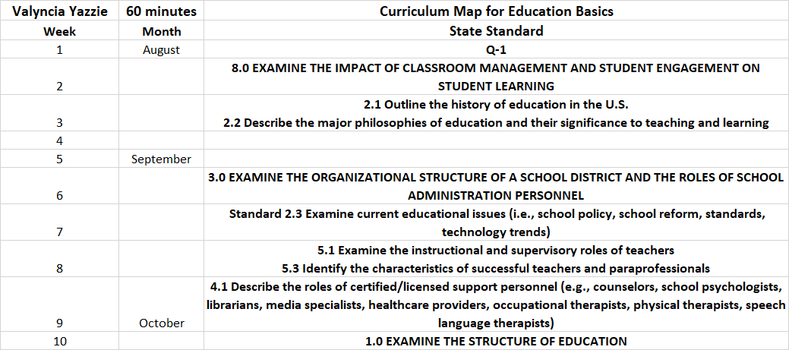
We are excited to have you in class and look forward to a great year! Have fun and learn lots!

